Battersea
Grants Management System
– Blackbaud Grantmaking

System Guide for Applicants and Grantees Spring 2021

Introduction to Blackbaud Grantmaking

Blackbaud Grantmaking - is a robust, fully auditable and customisable solution for grant management which streamlines and simplifies every aspect of grant management from receipt of proposal through to monitoring and evaluation and finally to closure. The system facilitates the collection and tracking of qualitative/quantitative information needed for assessment, payment, analysis, outcomes measurement and evaluation.

Blackbaud Grantmaking can manage and record interactions with applicants and grantees by generating email and paper correspondence from customisable templates or on an ad hoc basis.
External documents, such as annual reports / financial information and contracts, can also be stored electronically and linked to the appropriate records to be accessed at the click of a link.

The system also supports an online portal (to which this document refers) where applicants and grantees can access web forms (e.g. application and monitoring/evaluation forms) which link to the underlying database, thus minimising the need to re-enter information. External documents can also be uploaded with applications and reports and are then handled by the document management system built into Blackbaud Grantmaking.

Who else uses Blackbaud Grantmaking?
In England more than 1,000 organisations use the system including some of the largest Trusts and Foundations / grant making organisations, such as BBC Children in Need, City Bridge Trust, John Lyons, Wellcome Foundation, Age UK, and John Ellerman Foundation.

Help and support

The online Grantmaking system for applicants and grantees is designed to be largely ‘self -service’. Users can reset their own passwords and change their email addresses. They can also use the collaboration tools outlined at the end of this document to manage their applications and reports by sharing them with, or passing them to their colleagues.

However, some tasks can only be performed by the Battersea central grants team. For questions about the use of the system, contact them by emailing grants@battersea.org.uk

Getting started
To use the Battersea online Grantmaking portal, you will need to have an account.
You can use the login page to either log in to the system, or to create a new account.
Login page:
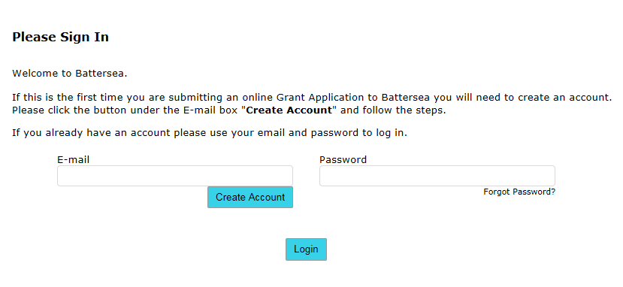

If you haven’t already got an account, click the ‘New applicant’ link and you’ll be taken through the process to create one. As part of this, you can create your own password.

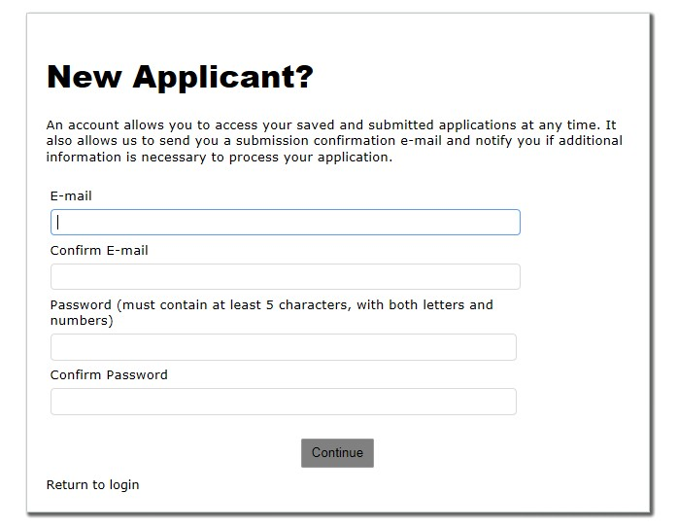
You can use the login page to either log in to the system, or to create a new account.
The login page can be accessed in two ways: by clicking a link on Battersea Website to access an application form, or by going directly to
https://www.grantrequest.co.uk/SID_117?SA=AM

You should only use the first method when you are starting an application for a new grant.

Forgotten Passwords and locked accounts
If you have forgotten your password or have a locked account, you can request a new password by clicking the ‘Forgot password’ link on the login page. You will need to enter your email address and may have answer some security questions. Providing you have entered your email address correctly, the new password will then be emailed to you.
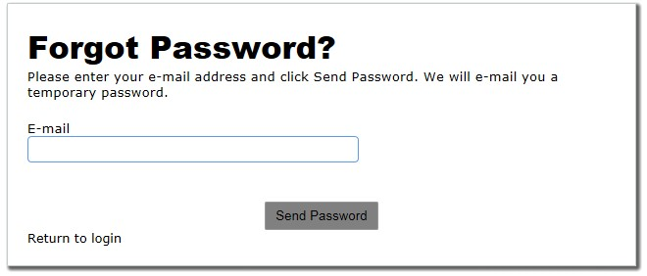

You will be asked to change your password the next time you log on. If this does not happen or solve the problem, please contact us in the first instance.

The Home Page
The home page of your online Grantmaking account is the starting point to access the applications you’ve already started or submitted and the monitoring report requirements for the grants you are managing. You can also change your email address or password from here.
Example Home Page:
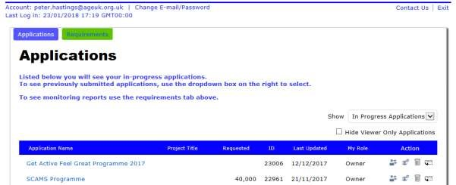

Finding your way around
There are two ‘tabs’ – one for applications and one for requirements (monitoring reports). The inactive tab is green, so in the screenshot above, you would click the green tab to see your requirements (monitoring report).
On both pages, there is a drop down list on the right where you can choose what to view. On the applications page, you can choose between ‘in progress applications’ and ‘submitted applications’. On the requirements page, there are three options:
‘new requirements’, ‘in progress requirements’ or ‘submitted requirements’.

New applications
Having set up an account, the applicant initiates the application process.
- To start a new application, click on the link on the Battersea Website for the appropriate grant programme. This will take you to the login page to your online Grantmaking account.
- After you log in, you will be taken to a new application form.
- You only need to do this once. To continue with an application you have already opened, simply log into your Grantmaking account and the application will be listed under ‘in progress’ applications. If you use the link on the grant programme page on the Battersea Website again, you will start another new application.
The questions on the application form will be different for each grant programme. The grant programme page on the Website will usually have a link to a document listing the questions for that particular programme.

New requirements
New requirements are ‘pushed’ up to your online Grantmaking account by the Battersea central grants team. This will generally be done around a week before the date they are due to be submitted. An email will be sent to the account’s email address when the requirement has been published.

Completing applications or requirements
The process for both is essentially the same. There are boxes on the form for the answers to the questions. Simply type your responses into the appropriate box.
Please note that some boxes will only accept the kind of answer they are expecting. The most usual example of where this might be important would be a question about expenditure or budgets. If an amount of money is being asked for, do not use a currency symbol (i.e. ‘£’). The system thinks this is text and is expecting a number! For example, just enter 123.45, not £123.45.
Boxes for narrative (free text) answers are more tolerant but pasting directly into them from an application like MS Word is not recommended when lists, bullet points or other complex formatting (e.g. tables) have been used. The layout is likely to be lost once the form is submitted.
The form isn’t automatically saved as you go along. It’s strongly recommended that you save your work manually from time to time. Once you have started working on a form, use the buttons and chevrons (if visible) to navigate your way around. Do not use the browser ‘back’ and ‘forward’ buttons. This may cause the loss of work.
The system is set to ‘time out’ after 120 minutes of inactivity, so if you are leaving your desk for lunch or a meeting, click ‘save and finish later’ before you go. After 60 minutes of inactivity, the user will get a pop-up warning message and after a further 60 minutes, they will get another message and will be logged out automatically. Any unsaved changes to the application will be lost at that point, but this only applies if there has been no activity for 2 hours.
You do not need to complete a form in a single session. You can save your work and return to it at a later time (but note that you may not be able to submit a form if a strict deadline is being enforced and passes).
Some responses will be required and you won’t be able to submit the form if these are left blank. Similarly, there may be limits to the length of some answers. When you try to submit a form, each field is validated and any problems will be highlighted for you to remedy.

Uploading files
Some questions may require you to attach one or more external documents. These may be templates for extra information about your project that is provided, or copies of supporting documents may be asked for, e.g. your annual accounts.
The form will prompt you to do this where necessary. Sometimes, a specific file type might be asked for (eg a PDF or an MS Excel file) and other types may be rejected (see FAQs below).
Similarly, if an attachment is required, you won’t be able to submit the form without one.

Submitting an application or requirement
Once you are satisfied with your form, you can review it and then submit it. This process validates all the fields on the form to make sure that the answers are not too long, don’t contain any unexpected data and that all the required fields have been completed.
Where there are any problems, you will be told that the form cannot be submitted and the fields with issues will be listed/highlighted. You should correct any problems and click ‘submit’ again.
Once the form has been submitted, the system will send you an email to this effect and the form will move from your ‘in progress’ list to ‘submitted’. You will still be able to view the form but will no longer be able to change it.

Collaboration
The Grantmaking portal has some functionality that enables collaboration between users, so that others can contribute to, or view, applications or requirements.
The screenshot below is from the right-hand side of a typical view of a list of requirements.

In the column headed ‘Action’, there are various icons that you are able to click to perform the relevant actions. By hovering the mouse pointer over them, you’ll see what the options are.
If you are the ‘Owner’ of the record (the 2nd and 3rd rows above), you have three options. You can:

- transfer the application\requirement to another GIFTS account (although note that the form will stay in your account until the transfer is accepted)
- give another GIFTS account viewer access
- email a copy of the form to a third party (who need not have a GIFTS account)
If your role is ‘Viewer’ (the 1st row), then all you are able to do is email a copy of the form to another email address.

FAQs
Below are some of the frequently asked questions that we are asked. If you can’t find the answer to your question, then please email us at grants@Battersea.org.uk
Am I able to log in to my account using my smartphone or tablet?
Yes you can, however please note that we do not have an app for this and so functionality may be limited on your device.
I want to access my online account but have forgotten/lost my password.
This is quick and easy to resolve. Go to the ‘Apply Here’ page and select the ‘forgot my password’ link. You will be asked to enter the email address associated with your account – you will then be emailed a link which will enable you to reset your password and login again.
The system is not accepting my details when trying to create a new account
This usually happens when an account for this email address already exists. Please click on ‘Forgot your Password?’ and follow the steps to have a temporary password sent to this email address, which then will allow you to change it to your preferred password.
Why isn’t the application form showing the right details?
Try clearing the cache and cookies of your browser. Try following the instructions at: www.wikihow.com/Clear-Your-Browser’s-Cache or www.aboutcookies.org/Default.aspx?page=2
Q At what stage should I add attachments?
At the appropriate sections in the application you will be asked for relevant attachments. Please note – if these are not attached you will not be able to submit the application.
Q Why does it say our files are not being accepted?
There are three likely reasons why the system is not accepting an attachment: Either the file is too large (needs to be smaller than 25MB). Or it’s an unrecognised file type (you can only upload files with the following file extension: pdf, doc, docx, and image files e.g. jpg.) Or it could be that the file is corrupted or has a password on the document. Please make sure that all passwords are removed before submitting documents.
Help and Support
If you have any questions or need help with applying online, please email us at grants@battersea.org.uk

