Battersea Research Grants Programme
Application and Delivery Guidelines
Winter 2021/2

Battersea Research Grants Programme Winter 2021/2

Application and Delivery Guidelines

About these guidelines
Please read these notes carefully before you start your Application. Should you have any queries about any aspects of the Programme, please contact Margaret Hulme, Grants Manager on grants@Battersea.org.uk

The deadline for submitting your Preliminary Application is 11.59pm GMT on 1st August 2021.

Section |  | Page
Section 1 | Background of the Programme | 3
Section 2 | Aims of the grant programme | 3
3 | Process | 3
4 | Key Criteria | 3
5 | Who can apply? | 4
6 | Value of Funding and Support Provided | 4
7 | Duration | 4
8 | How we will assess your application | 4
9 | How we will review your application | 5
10 | References and Participants | 5
11 | Use of Data | 5
12 | Publications | 5
13 | Communications | 6
14 | Intellectual Property Rights | 6
15 | Change of Principal Investigator or supervisor | 6
16 | Termination | 6
17 | Timetable | 6
18 | System Guidance | 7
19 | Application Guidance Notes | 7
 | Contact information | 9
 | Appendix – Priority list of key topics | 10

Introduction to the Battersea Research Grants Programme

Battersea are delighted to launch their Research Grants Programme. This is a new grants programme designed for academic institutions and other organisations, to develop new research on animal welfare within the shelter environment and in the home following adoption, whilst at the same time gaining invaluable insight and knowledge to share with the wider sector.

Please note – no application will be considered if it involves work under the Animals (Scientific Procedures) Act 1986.

Section 1: Background to the Programme
Battersea are working to help organisations both across the UK and Internationally, manage and care for their stray population. This ranges from providing grants & education, to providing advice on animal welfare matters as they affect organisations operating within the sector.

Section 2: Aims of the Programme
The Research programme will provide up to £40,000 ‘seed corn’ funding for up to 12 months to independent researchers or principal investigators within HE and other educational institutions, in order for them to develop research projects linked to an aspect of shelter welfare in dogs and / or cats. (e.g. quality of life, welfare, kennel / cattery environment, behaviour, veterinary advancement in shelter medicine).

A priority list of research topics is provided at appendix 1.

For our second round of 2021/22 our focus will remain on research in the UK. We look to welcome applications from overseas in subsequent years as we recognise research is increasing being recognised by countries worldwide as an important step forward in shelter welfare.

The Grants Committee will consider applications that fall within Programme guidelines.

We anticipate a big demand for grants and so cannot offer any guarantees that funding will be provided to all eligible applicants.

Section 3: Process Overview
This is a two stage process.
A Short Preliminary Application summarising the project must be submitted which will undergo Peer Review. Those whose work is considered to be of relevance and interest will then be asked to submit a Full Application within a specified period.

Section 4: Key Criteria
Research must be within Battersea’s remit of caring for Companion Animals, specifically dogs and cats.

Section 5: Who can apply
Applicants must
- Hold a PhD or equivalent qualification.
- Be based at an eligible / recognised organisation / academic institution.
- Be within the first five consecutive years, at the time of application, of either (whichever is the earliest): their first permanent independent academic research post, or a named limited-tenured/fixed-term academic research post, obtained in open competition
(Note that tenure must cover the duration of the award).
- Be fully independent researchers with access to their own lab space and with the ability to recruit and to be registered as the primary supervisor of PhD students and research assistants (Career Development or Tenure Track
- Additionally, applications may also be considered from independent researchers (i.e. principal investigators) who have recently returned to academia (within the last 6 months at time of application), following a career break from research.

Alternatively an application may be made by the primary investigator of a group of investigators. The primary investigator should be the person spending the majority of their time on the project or, if not appointed (in the case of a PhD) their immediate supervisor.

Each case will be considered individually and on its own merits.

Section 6: Value of funding and support provided
Up to £40,000 (to include VAT) is available for each proposed project, and legitimate expenditure may include the purchase of specialised equipment directly related to the proposal (and not available to the applicant from their host institution or other sources), essential consumable materials, travel and subsistence for essential field work.

Section 7: Start and Duration
Awards are expected to commence in early 2022 and are for a period of up to 12 months.

Section 8: How we will assess your application
The assessment criteria is:
• the quality/capability of the applicant
• the degree of independence and involvement of the applicant in the pursuit of the new research
- fit with Battersea’s priority research projects
- budget of proposal
• the quality and novelty of the new research (e.g. initiating or developing specific investigations, entering a promising new or modified field of research, or taking advantage of developments in apparatus offering improved techniques in a new line of research)
• the feasibility of the proposed research plan
• the potential application(s) of the proposed research work
• welfare implications
• the likely success of the project within the period
• the possibility of obtaining further funding resulting from the proposed research,
• the potential benefits to the applicant(s) and companion animals.

Section 9: How we will review your application
Applications are assessed by the Research Grant Committee. The Panel Chair will agree on a list of applications that should be funded and also a reserve list.
Please be assured that Battersea will specifically request anyone involved in reviewing applications to consider them in confidence. More information on the Review Process can be found in Appendix 1.
All applicants will be notified of outcomes via email.
Section 10: References and Participants
It is the applicant’s responsibility to ensure that the required tasks are completed by the deadline. Please contact Battersea before the deadline if there is any issue. Battersea will not be held responsible for emails that are not received due to address errors or spam filters.

It is recommended that applicants fulfil their requirements at least 5 working days before the submission deadline (1st August 2021).

Section 11: Use of Data
Please note that information regarding your application for a Battersea Research Grant may be shared with internal colleagues for data monitoring and scheme evaluation purposes. You may also be contacted by selected third parties such as independent evaluators, consultancy groups, and career development organisations.
If successful, Battersea will contact you regarding the administration of your award throughout the course of your funding and after its completion. You may also be contacted by Battersea or an agent acting on their behalf, for reporting and evaluation purposes throughout the course of your funding and after its completion.
Section 12: Publications
At least one substantial paper should be published in refereed and appropriate non-refereed journals. Publication of clinical papers in refereed journals is expected during, or in a timely manner after, the conclusion of the grant. Details of these publications are required and should be sent to Margaret Hulme prior to submission. An electronic copy of the final publication must be forwarded to Margaret Hulme (m.hulme@battersea.org.uk)

The support of Battersea must be acknowledged in written publications and oral presentations arising from the grant. Battersea must be notified prior to publication or presentation. Publication costs can be accounted for in the final budget to a maximum of £2,000.

Section 13: Communications / PR
You must notify Battersea of any upcoming publications or communications surrounding a grant in order to prepare necessary statements and responses.

Section 14: Intellectual Property Rights
The ownership of any Intellectual Property Rights (IPR) arising from the Project shall be agreed in writing between Battersea and the application before the project commences.

IP Rights resulting directly from research conducted via the grants made by Battersea, shall be owned by the research Institution. The research institution shall not unreasonably withhold permission to allow Battersea to use any IP rights resulting directly from research via the grants made by Battersea, and the research institution should seek prior written approval from Battersea to file a patent or for any commercial exploitation of results arising from the funded project. Approval by Battersea may be granted subject to conditions such as the right to share in the benefits arising from any exploitation.

Section 15: Change of Principal Investigator or supervisor
If the principal investigator or supervisor moves to another institution, or if a change becomes necessary for any reason, approval for the grant to continue must be sought from Battersea and received in writing in advance.

Section 16: Termination of Grant
Battersea reserves the right at any time and without notice to terminate a research grant and withdraw grants in full or in part on grounds of unsatisfactory progress or failure to comply with these Terms and Conditions or for any other reason. In such cases, a notice period would be agreed with the host institution. Battersea will reimburse expenditure properly incurred up to the date of termination, will withdraw the grant from the next month onward after this date, and will not be liable for any matters or circumstances, including financial after this date.

Section 17: Timetable
1st August 2021 – deadline for Preliminary Application
Week Commencing 20th September 2021 – Applicants who have been selected to complete a full application will be invited to make a submission
Friday 15th October - Deadline for a full application
Week Commencing 29th November 2021 – Applicants informed of outcome

Section 18: System Guidance

Stage One - Preliminary Application
Please note this is a simple word document. Please note the word count. Applicants exceeding the count will be penalised

Stage Two – Full Application
A full application needs to be submitted via our Grant Management Portal – Blackbaud Gifts -
Please see separate document on BLACKBAUD GIFTS. You must first create an Account before accessing the Stage One Preliminary Application Form. Failure to do this will mean your information will not be saved within the system.

Section 19: Application Guidance
Please note this is a 2 Stage Process.

Stage One – Preliminary Application summarising the Project
If successful, applicants will be asked to complete Stage Two - Full Application

Please read the following guidance notes carefully as you complete the form(s).

Note that questions with * are mandatory fields.

Stage One – Preliminary Application
Applicants will be asked for the following information:
- Title of Project
- Duration of Project
- Cost of Project (including any publication costs)

- Principal Investigator information (i.e. the most experienced person taking responsibility for the grant)
Title, name and qualifications
Institution, Department, Position held
Address, email and telephone number(s)

- Secondary Investigators. If there are others who will be involved in the project please note them:
Title, name and qualifications
Institution, Department, Position held
Address, email and telephone number(s)

- Lay Summary of proposed project (max 500 words)
Please ensure you complete this section in layman’s terminology

- What are the key objectives of the project?
Max – 5 bullet points

- Please summarise the impact and relevance of the project to dogs and/ or cats either in the shelter environment or in their adopted home. (max 500 words)

Stage 2 – Full Application
Summary
The summary page of the application form provides instructions for submission of
your application together with key dates

Eligibility Criteria
You will be asked to provide confirmation that you meet the eligibility criteria.

Contact Details
Please make sure you complete your personal details accurately. Errors in this section can cause difficulties in processing your application.

Applicant Career Summary
- current position
- official organisation name of your current employer (e.g. University of Nottingham)
- details of your current department
- date when your current position started
- date when your current position is expected to finish.
- your field of specialisation
- your qualifications
- your current research and your key / relevant publications to date
- your current and previous research funding

Research Proposal
- Please give the full title of your proposed project (20 words max)
- Start and end date
- Lay summary of the proposed research: This should be understandable by a lay person. Please explain why you have chosen to work in this subject area, and what it is about your proposed research that you find particularly exciting, interesting or important. Please also explain the potential impact or wider benefits to the sector. (250 words max)
- Research Proposal: Please provide the details of the proposed programme of work, commenting specifically on what your scientific question is, why it is important and what you experimental approach will be during the duration of the award. (500 words max)
- Relevance to earlier work: Please state the relevance of the proposal to earlier work (200 words max). Please provide information how the proposal relates to your own earlier work.
- How does this proposal differ from your current research? Please confirm this is a new project and that you will be taking a lead role in this project. Please also confirm that this grant will not supplement ongoing research, existing grants, or continuing an existing lime of research (500 words max)
- Rationale: please provide a brief statement explaining the impact this proposal may have on your research – how the proposed work will benefit the research and development of the applicant (250 words max)

Date Management
Please tell us:
- what data outputs will be generated by the research that will be of value to Battersea / the sector
- where and when you will make the data available
- how will others be able to access the data
- will there be any limits placed on the data to be shared – eg safeguarding commercial interests, personal information, safety or security of the data

Financial details
- Proposed budget: please provide a summary of your requested budget. This should not exceed £40k.
- Justification for research expenses: please fully justify your request for all research expenses. A clear justification for all consumable and travel costs must be provided.
- Please fully justify your request for any equipment.
- Please state all other sources of funding ( secure or otherwise ) the mounts and the purposes of each. This refers to any funding related to the proposed project.
- Please upload relevant documents (PDF) such as a quotation for equipment or a letter from the Head of Department confirming priority usage of any equipment you intend to purchase.

Applicant declaration
Please declare:
- that you have read the Terms and Conditions of Award under which any Battersea grant is awarded and if a grant offer is made, you agree to abide by them
- that you have access to the necessary facilities to enable you to deliver the research proposed and will continue to have access to the facilities for the duration of the project
- you have agreed with your Head of Department that you will be afforded the time and resources to deliver the research project as described in this application .

Section 20: Contact Information
For further information and to request an Expression of Interest Application Form -
Margaret Hulme (Grants Manager) m.hulme@battersea.org.uk
Appendix A

Identified potential dog research areas and examples of potential options.
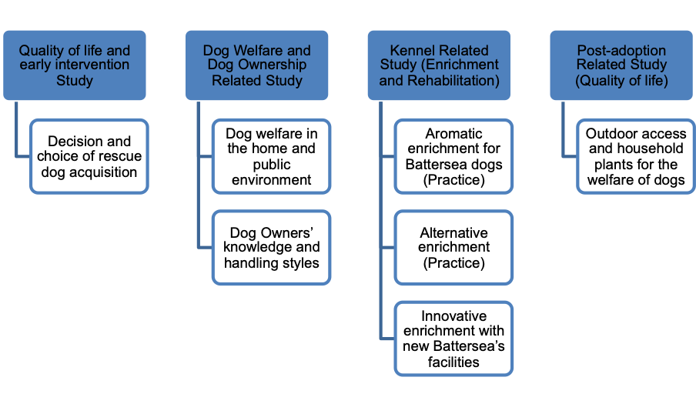

Identified potential cat research areas and examples of potential options.
